Lesson 5: Quiz

CS544 Enterprise Architecture

Annotate the following code to map exactly to the tables on the right of the question.   
Please also answer the theory questions on the back of the page

|  |  |
| --- | --- |
| public class Vehicle {      private Long id;      private String owner;      private String make;      private String model;      private int year;      private String color;      private List<Wheel> wheels;  }  public class Bike extends Vehicle {      private int numgears;  }  public class Wheel {      private Long id;      private int size;  private double pressure;  } | mysql> describe Vehicle;  +--------------+--------------+------+-----+---------+----------------+  | Field | Type | Null | Key | Default | Extra |  +--------------+--------------+------+-----+---------+----------------+  | DTYPE | varchar(31) | NO | | NULL | |  | id | bigint(20) | NO | PRI | NULL | auto_increment |  | color | varchar(255) | YES | | NULL | |  | manufacturer | varchar(255) | YES | | NULL | |  | model | varchar(255) | YES | | NULL | |  | year | int(11) | NO | | NULL | |  | numgears | int(11) | YES | | NULL | |  +--------------+--------------+------+-----+---------+----------------+  mysql> describe Wheel;  +--------------+------------+------+-----+---------+-------+  | Field | Type | Null | Key | Default | Extra |  +--------------+------------+------+-----+---------+-------+  | id | bigint(20) | NO | PRI | NULL | |  | pressure | double | NO | | NULL | |  | size | int(11) | NO | | NULL | |  | wheels_id | bigint(20) | YES | MUL | NULL | |  | wheels_ORDER | int(11) | YES | | NULL | |  +--------------+------------+------+-----+---------+-------+  mysql> describe Owners;  +-------+--------------+------+-----+---------+-------+  | Field | Type | Null | Key | Default | Extra |  +-------+--------------+------+-----+---------+-------+  | owner | varchar(255) | YES | | NULL | |  | id | bigint(20) | NO | PRI | NULL | |  +-------+--------------+------+-----+---------+-------+ |

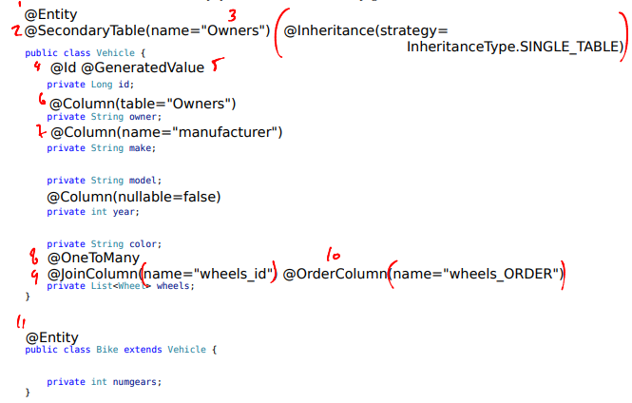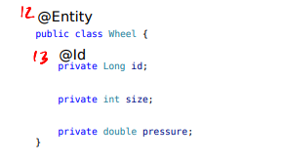

1. What are the 3 ways to map inheritance?

Single table

Joined tables

Table per concrete class

1. What is a value class, and how is it different from an entity class?

A value class is an @Embedabble, it goes inside an entity, becomes part of the entity's table. It does not have an @Ids